**Why Use LinkedIn for Networking?**

**Employers Flock to LinkedIn**

[In the U.S. alone](https://economicgraph.linkedin.com/resources/linkedin-workforce-report-july-2018),

* 149 million workers have LinkedIn profiles.
* 20,000+ companies recruit on LinkedIn.
* Over 3 *million* jobs are posted *a month*.
* Using LinkedIn is a smarter way to build your professional network. Did you know, [40% of jobs are hired through referrals](https://theundercoverrecruiter.com/infographic-employee-referrals-hire/)?! Ensure you're connecting with others across your field using LinkedIn - they'll help you find your next job and grow professionally.

# How to Stand Out

**Imagine:** You're a hiring manager and need to pick 5 people to interview for a role. You get 50 applications, and everyone seems pretty qualified. How do you compare job candidates? You'll probably pick the candidates that stand out the most to you - likely the people who communicate their motivation and dedication for the job.

## Personal Stories

A job candidate's personal story is always unique to them. Employers aren't just looking for someone with the skills, but for someone who can help drive the company's mission forward. That's why they need to know your work ethic and what drives you.

Personal stories are memorable. Connect with your potential boss or colleague by telling your personal story. You want employers to know how you solve problems, overcome challenges, and achieve results. You want employers to know what excites you, what motivates you, what drives you forward.

**All of this can be achieved through effective storytelling and building a personal brand.**

In this next video, meet **Chris Saden, a software engineer at Udacity,** who will share with us how he redefined his personal brand during a career change from admissions counselor to full stack engineer.

# Communicate Your Elevator Pitch in your LinkedIn Summary

Let's take another look at Chris's elevator pitch:

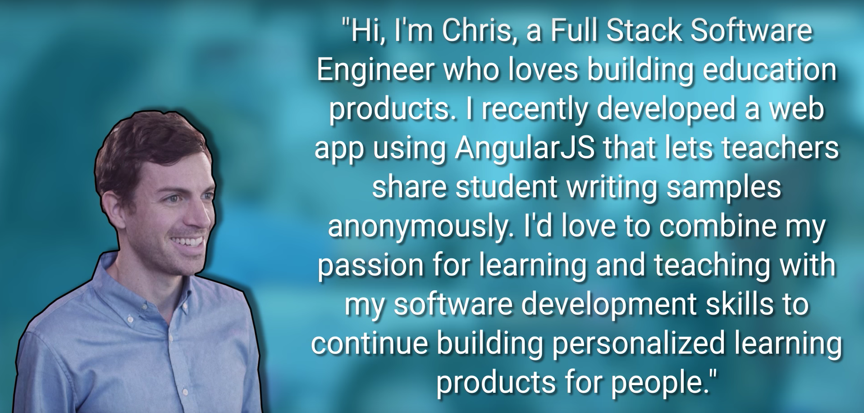

*Hi, I’m Chris, a Full Stack Software Engineer who loves building education products. I recently developed a web app using AngularJS that lets teachers share student writing samples anonymously. I’d love to combine my passion for learning and teaching with my software development skills to continue building personalized learning products for people.*

Use the same talking points for your LinkedIn summary, which may be the first thing people read on your profile. When recruiters (or anyone else) search on LinkedIn, keywords from your summary contribute to your rank in search results.

### LinkedIn Summary Guidelines

* Keep the summary to 3-5 points maximum.
* Use numbers where possible.
* Always use active instead of passive language.
* Include a call to action so that people are more likely to contact you for more information.
* See how Chris uses the same elevator pitch to craft his LinkedIn summary:

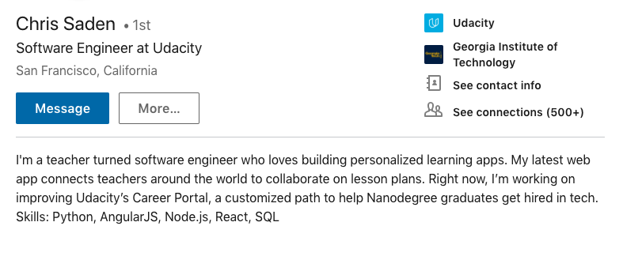

## Before we continue:

If you already have a LinkedIn profile - fantastic! Use this section to investigate, revise, and improve the highlighted sections.

If you don't have a LinkedIn profile - you will soon! Open up [LinkedIn](https://www.linkedin.com/) in another browser tab and create an account. You can expect to spend about 10 minutes going through LinkedIn's "Welcome" flow.

## Keywords and SEO

As there are millions of LinkedIn users, you may be wondering how you stand out or are surfaced to recruiters. Below, we dive into the sections of your profile which are essential to SEO (search engine optimization - or optimizing your profile for searches on LinkedIn).

On your LinkedIn profile, more-so than on a resume or other application materials, it is helpful to use keywords specific to the job you are targeting. This is especially true of the words you include in your headline, summary, and current job title. Think of the words that a recruiter might type to search for candidates of your target job and check to ensure they're listed in your profile.

For example, if you were looking for a job developing mobile augmented reality apps, you might want to include words like engineer, iOS, Android, Unity, or 3D.

Pro Tip*: To find keywords to add, read job descriptions of positions you are targeting.*

For example, when you search "Udacity Software Engineer" on LinkedIn, you may find similar results to the image below. What do you notice about the search results?

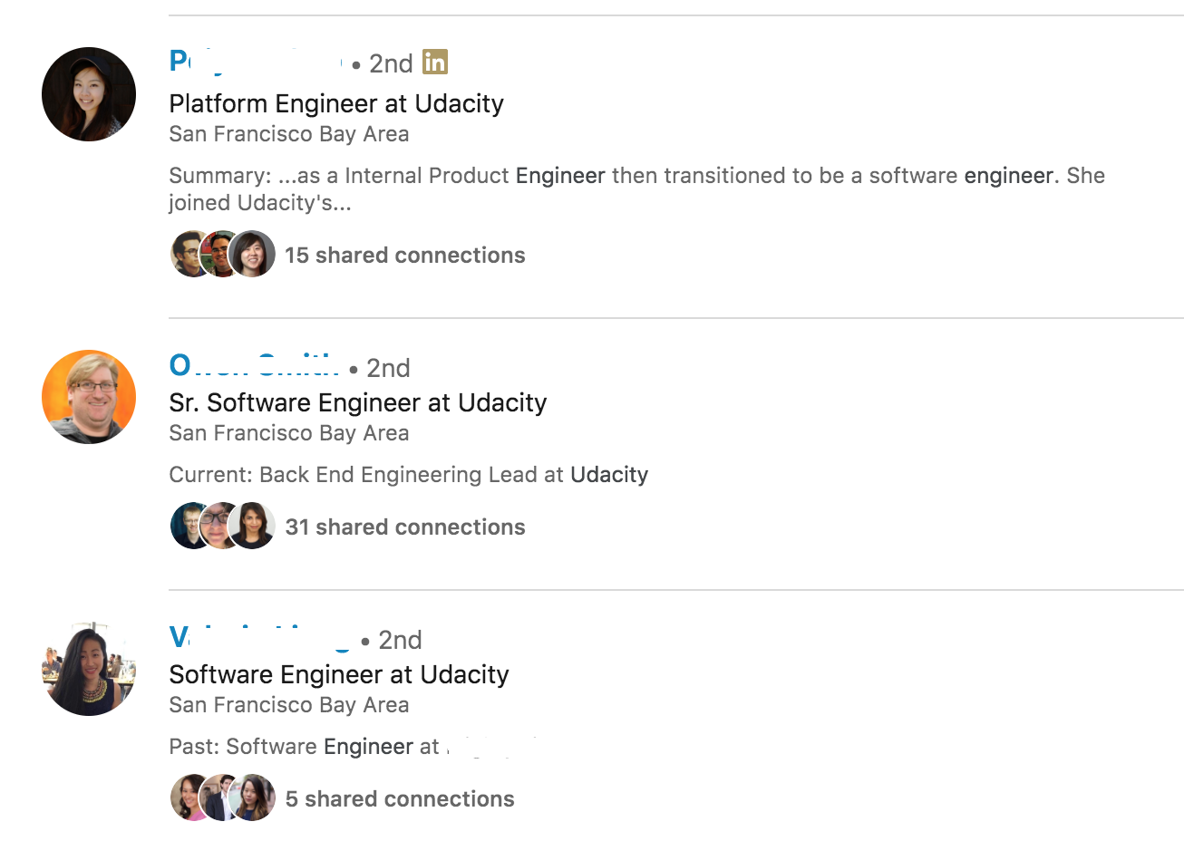

You may have noticed that:

1. All have profile pictures.
2. All have the keyword "software engineer" in their Headline, Summary, and Past Experience sections.
3. All are second connections with the searcher. The people you're 1st, 2nd, and 3rd connections to will be prioritized in your search results. If you want to be surfaced in search results, you'll need to connect with others in your industry to boost your visibility.

Up next, let's take a closer look at your profile picture, name, headline, and summary. We'll cover your experiences and connections later in the lesson.

# Spend some time getting these essentials right.

## Name

Here you will need to use your real name, not a pseudonym. No Codergirl42, no HireMe McJoberson, just your real first and last name.

Pro Tip:*You can add former names to your Profile. See*[*instructions*](https://www.linkedin.com/help/testing/answer/1288/former-or-maiden-name-on-your-profile?lang=en)*from LinkedIn.*

## Profile Picture

#### Do

* Upload a picture cropped to your head and shoulders.
* Aim for a high resolution photo.

#### Don't

* No inappropriate or unprofessional items or environments.
* Don't include other people - this is your profile after all!
* No selfies. Someone is willing to take a photo for you, we promise!

**Headline**

Your headline should be one of the following options:

* **Your Current Job Title**. This is the simplest but most effective way to optimize SEO; LinkedIn even defaults to suggesting you do this.
* **Your Education**. If you do not yet have a job in your new industry, add your education such as "Data Analyst Nanodegree Graduate." You still include the key term "data analyst".
* **Your Target Job**. Remember when Chris said his job search improved when he finally called himself a software engineer? If you're a Nanodegree graduate with a portfolio of real-world projects to share, feel confident and list your target job title.

**Summary**

You should already have your summary, crafted from your elevator pitch, from the exercise with Chris. If you need a refresher, just go back to "Use Your Elevator Pitch on LinkedIn." Your summary should:

* Be written in first person, with a professional but conversational tone.
* Include your key abilities and contributions.
* Include 5 key skills (programming languages, software, etc.) for SEO purposes.
* For reference, here's Chris's summary:



## Showcase Successful Work Experiences

The Experience section of your LinkedIn profile should mirror your resume. Ensuring your resume and LinkedIn are consistent will help to build your personal brand.

In our [free course on resume writing](https://www.udacity.com/course/refresh-your-resume--ud243), we provide detailed guidance on how to describe your work experiences in a way that showcases success. Here are some guidelines to keep in mind for both resumes and LinkedIn profiles:

#### Be concise.

* Include only relevant experience.
* Keep each description to 3 bullet points or less.
* At least 1 of these bullet points should demonstrate an individual contribution.
* At least 1 of these bullet points should communicate a project result (success metrics, findings).

#### Always convey [Action, Numbers, Success](https://classroom.udacity.com/courses/ud243/lessons/db219674-a784-45f9-9829-d16a7a252bd0/concepts/3a826d6e-4610-4590-a896-20d2a2427f3e).

* Action - Use active verbs to describe what you did.
* Numbers - Quantify your accomplishments.
* Success - Define each experience in terms of what you learned or achieved.

#### Order matters.

Make sure that your most relevant and most recent experience appears at the top of your profile.

## Accomplishments

You can adapt the "Accomplishments" section of your LinkedIn profile to a wide variety of work experiences and achievements. For example, the "Accomplishments" section for "Projects" is an excellent place to **showcase your Udacity projects!** You can also list the Udacity courses you have taken in the "Accomplishments" section for "Courses."

When describing your projects be sure to include the specific technical skills you learned relevant to your target field. Think about the parts of your Udacity projects that you are most proud of and frame them as successes in your project description. Here are a couple good examples from Udacity alums:

[Kristin, Virtual Reality Developer Nanodegree Program Alum](https://www.linkedin.com/in/kristindragos/) - Notice how Kristin uses the project section to showcase the technologies she has worked with (i.e. Unity, Oculus Rift). She also provides links to visuals for each project, so that it's easy for recruiters and connections to dive deeper into a project that piques their curiosity.

[Michael, Self Driving Car Nanodegree Program Alum](https://www.linkedin.com/in/michael-virgo/) - Notice how Michael uses the "Projects" section to include more details about his experience with autonomous vehicles, and highlights his use of particular models like convolutional neural networks.

**Find More Connections**

In order to use your LinkedIn profile effectively, it's important to have as many connections as possible. In general, 500+ connections are needed to fully optimize your profile.

This may seem like a lot, but once you get rolling, you'll get to that number fast. After you actively start engaging on LinkedIn, by joining groups and going to networking events, your number of connections will climb. You are more likely to show up in search results on LinkedIn if you have more connections, which means you'll be more visible to recruiters.

Here are some examples of the types of connections you could add:

* current and former colleagues
* people you attended school with (high school, university, graduate school, Udacity)
* your favorite teachers and professors
* people you meet at professional events, like conferences and meetups
* volunteering companions
* friends and relatives
* roommates and neighbors

Need some incentive to get started? No time like the present. Finish the tasks below and check them off as you go!

## Join Groups

Joining groups allows you to see content from and post content to people who share your interests. Join groups which relate to your industry, of professionals who live near you, or of people who attended the same alma mater. For example, it is common for people to join location-based professional groups, like the Chicago Young Professionals, or for Udacity students to join the Udacity Alumni Network. You might want to join groups associated with specific technologies, like Swift Developers, User Interface Design, or Self-Driving Cars.

Joining groups vastly increases the number of people in your network, increasing the visibility of your profile and the number of opportunities that come your way.

Optimizing your LinkedIn Profile is important for showcasing yourself to any recruiter or employer. However, you can do more than passively wait for someone else to reach out.

After improving your LinkedIn Professional Profile, connect with other industry professionals via LinkedIn to set up an informational interview, learn about a position, or build new professional relationships.

### Example LinkedIn Conversation

Platforms like LinkedIn make it easy for people to find and connect with each other. **When you connect with someone, make sure to write a note in the request.** You only have 300 characters in a connection request to make a first great impression. Below is an example of how you might request an informational interview.

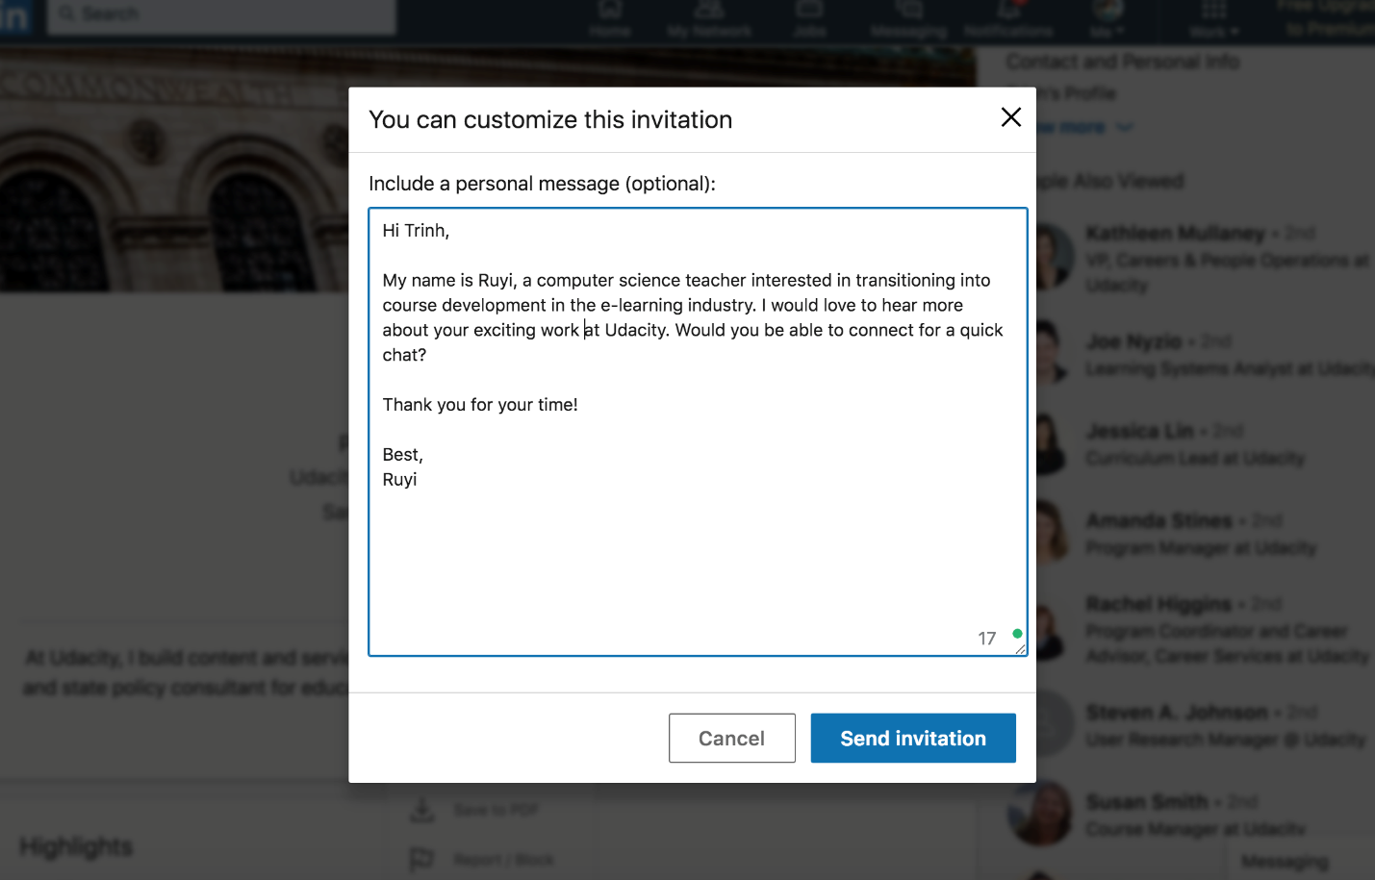

Once they've accepted your invitation to connect, you can move forward with sending your request to meet for an informational interview.

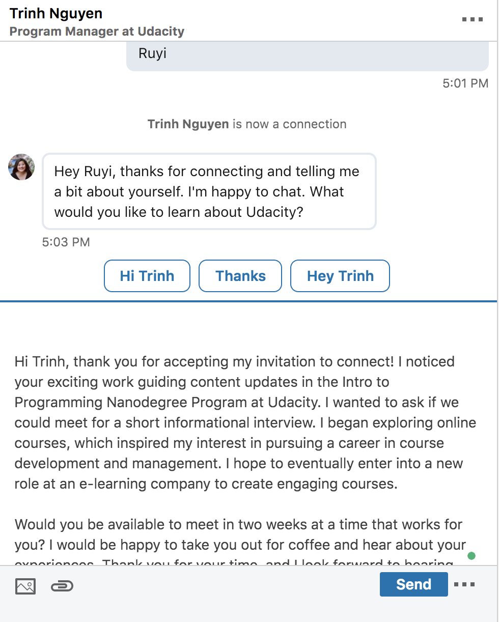

**Don't forget: It's expected that one will receive connection requests through LinkedIn.** There's no reason to think you're inconveniencing the other person. Like you, other people are interested in improving professionally, which can revolve around sharing their own experiences and knowledge or discussing current topics of interest in the industry.

**Not sure how to start making connections?** Review our [advice in the Career Resource Center](https://career-resource-center.udacity.com/networking/informational-interviews) on how to successfully request and conduct an informational interview.

You may feel nervous or unsure at first, but with practice and frequent networking interactions, you will soon become a networking pro.

NEXT

# You've optimized your profile. What's next?

Creating a killer profile is a key first step toward building a strong LinkedIn presence, but there is a lot more you can do to nurture your connections and make your profile easy to find. Here are some of the avenues LinkedIn provides to engage with your professional community.

### Follow

Follow the influential companies in your target field to stay informed about new discoveries, trends, and current events in your professional sphere. Identify companies where you can imagine working, and follow those too; you'll see job posts sooner and you'll be more likely to show up in their recruiters' searches.

### Post, Like, and Comment

Authoring original posts is a fantastic way to boost your visibility, but if you are a little shy about posting at first, don't worry. Plenty of people get meaningful value out of LinkedIn without authoring posts. You can also engage by liking and commenting; these small actions can go a long way toward boosting your visibility.

### Endorse and Recommend

There are so many good reasons to endorse and recommend on LinkedIn. **Effective team players recognize the contributions of others.** By endorsing and recommending current and former colleagues you can show future coworkers that you are capable of acknowledging your teammates. This acknowledgement will also deepen your relationship with the colleagues and collaborators you endorse, not to mention it will increase the likelihood of someone acknowledging you in return.

Here's a profile from [Mike, a former Udacity employee](https://www.linkedin.com/in/michaelwales/). Take a look at his "Recommendations" section. Notice that he has received and given multiple recommendations. Not only does this give us a window into working with Mike, but it shows that he's a colorful and clear communicator.